TCS AgentAssist 1.0
User Manual V1.0

August 28, 2026

Notice
© 2026 Tata Consultancy Services Limited
This is a controlled document. Unauthorized access, copying, replication or usage for a purpose other than for which it is intended, are prohibited.
All trademarks that appear in the document have been used for identification purposes only and belong to their respective companies.

Tata Code of Conduct
We, in our dealings, are self-regulated by a Code of Conduct as enshrined in the Tata Code of Conduct. We request your support in helping us adhere to the Code in letter and spirit. We request that any violation or potential violation of the Code by any person be promptly brought to the notice of the Local Ethics Counselor or the Principal Ethics Counselor or the CEO of TCS. All communication received in this regard will be treated and kept as confidential.

Document Release notes
Customer : TCS Internal
Project : AgentAssist

Document Details
Name | Version Number | Description
TCS AgentAssist 1.0 User Manual V1.0 | v1.0 | Initial version

Approved by : Savitha Ekambaram Authorized by : Kameswara Rao Chebrolu
Date : 25-Aug-2026 Date : 25 Aug-2026

Document Revision List
Customer : TCS Internal
Project : AgentAssist
Document Name : TCS AgentAssist 1.0 User Manual V1.0

Release Notice Reference (for Release)
Revision Number | Revision Date | Revision Description | Page Number | Previous Page Number | Action Taken | Addenda/ New Page | Release Notice Reference
1.0 | August 25, 2026 | v1.0

About this Document
Purpose
This manual explains how to use the AgentAssist application, and it consolidates functional and operational guidance required to efficiently handle airline bookings across the complete booking lifecycle.
Intended Audience
This document is intended for:
- Service Center Agents responsible for handling customer interactions
- Business users responsible for defining and managing the capabilities of the Airline Service Center channel.
Authorized Use Permission
This document is authorized to be used by the owners of the AgentAssist application only. Any unauthorized access, copying, replication, or usage for a purpose other than for which it is intended, is strictly prohibited.
References
Document Name | Description | Location
Abbreviations
Abbreviation | Expansion
NA | Not Applicable
TCS | Tata Consultancy Services
UI | User Interface
PNR | Passenger Name Record
ARD | Amadeus Reservation Desktop / ARD Web
IATA | International Air Transport Association
SKU | Stock Keeping Unit
URL | Uniform Resource Locator

Table of Contents
1 Introduction 9
1.1 Scope of AgentAssist 9
2 Getting Started 10
2.1 How to navigate to AgentAssist 10
2.1.1 From Salesforce Order panel 10
2.1.2 Using the Global URL 11
2.1.3 Logging Out 11
3 Create Order 11
3.1 Steps to create order 11
3.2 Locate “Create Order” 12
3.3 Search Offers 12
3.3.1 Customer information retrieval from CRM-Salesforce to AgentAssist 13
3.3.2 Steps to Search for Flights 14
3.3.2.1 Trip Type 14
3.3.2.2 Travel Details 15
3.3.2.3 Passenger Information 16
3.3.2.4 Enter Optional Details (If Applicable) 17
3.3.2.4.1 Discount Code 17
3.3.2.4.2 Loyalty Program 17
3.3.2.4.3 Member ID 18
3.3.2.4.4 Class Type 18
3.3.2.4.5 Promocode 18
3.3.2.5 Search and Validation 19
3.4 Review Offers 19
3.4.1 One way review screen 19
3.4.2 Round trip review screen 20
3.4.3 Flight Results Overview – Offers, Filters, and Fares 20
3.4.3.1 Header section 20
3.4.3.2 Filtering options 20
3.4.3.3 Sorting options 20
3.4.3.4 Flight Results Table (Main Section) 21
3.4.4 Managing Filters and Search Options 21
3.4.5 Information Icon – Flight Details 21
3.4.6 Information Icon – Pricing Details 22
3.5 Select Offer 23
3.5.1 Fare Family Review 23
3.5.2 Offer Selection 24
3.5.3 Cart Creation and Management 24
3.6 Passenger Details 26
3.6.1 Passenger Details Entry 27
3.6.2 Contact Details Entry 28
3.6.3 Validation Rules 28
3.6.4 Passenger Data Submission 29
3.7 Seats and Services Selection (Optional) 30
3.7.1 Screen Overview 30
3.7.2 Seats Selection 30
3.7.3 Services Selection 31
3.7.4 Cart Review 32
3.8 Order Confirmation 33
3.9 Payment 33
3.10 End-to-End Booking Flow (Visual Diagram) 34
3.11 Use Case: Family Booking (Adult + Child + Infant) 36
3.11.1 Detailed Scenario Understanding 36
3.11.2 Step 1: Understand Customer Need 36
3.11.3 Step 2: Search Configuration 37
3.11.4 Step 3: Flight Selection Strategy 37
3.11.5 Step 4: Fare Selection Logic 37
3.11.6 Step 5: Passenger Entry 38
3.11.6.1 Adult: 38
3.11.6.2 Child: 38
3.11.6.3 Infant: 38
3.11.7 Step 6: Contact Details 38
3.11.8 Step 7: Seat Selection Strategy 38
3.11.9 Step 8: Services Selection 38
3.11.10 Step 9: Final Review 39
3.11.11 Step 10: Confirmation and Payment 39
4 Appendix A 40
4.1 System Guidelines and Additional Notes 40
4.2 Common Validation Rules and System Messages 40

Introduction

AgentAssist is a comprehensive booking management application that helps airline customer service agents to handle bookings efficiently. It allows agents to:
- Manage the complete booking journey
- Assist customers quickly and accurately across a wide range of service scenarios.
- View, select, and modify seats using an interactive seat map.
- Seamlessly connect with the Amadeus Nevio platform to ensure accurate and up-to-date booking data.
- Identify ancillary services such as seat upgrades, additional baggage, and other value-added products.
Overall, the system supports agents in delivering high-quality customer service and contributes to increased operational efficiency and revenue generation.

Scope of AgentAssist
This document covers the end-to-end booking journey with AgentAssist including:
- Searching for flight offers
- Viewing and comparing offers
- Managing selections in the cart
- Capturing passenger and contact details
- Selecting seats
- Adding ancillary services
- Creating and confirming orders

Getting Started

How to navigate to AgentAssist
You can access the AgentAssist in the following ways, depending on your role and entry point.

From Salesforce Order panel
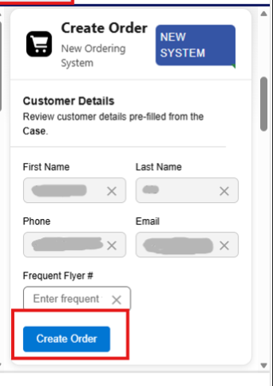
- Open the required case record in Salesforce.
- Locate the existing Reservation component that is currently used to open ARD Web.
- Under the Reservation component, identify the new Create Order component.
- Customer data is prefilled from customer data in Salesforce. Edit the details if required.
- It is not mandatory to enter or modify customer data. You can proceed to the new system without providing any details as well.
- Click the Create Order component to launch the new system.
- The system opens the AgentAssist in a new tab, where you can continue with order creation.
- Customer information (First Name, Last Name, Phone, Email, Frequent Flyer) is automatically fetched from Salesforce.
- The customer details are populated at the top of the search panel in the AgentAssist.

Using the Global URL
TCS Global Link provides direct integration between the Finnair Service Console and AgentAsssit application.
- Agents can access AgentAssist by clicking on the TCSGlobalLink tab available in the bottom navigation bar.
- Upon selection, the AgentAssist application opens in a new browser tab.
- No customer, booking, or case information is pre-populated.
AgentAssist UI Environment URLs
Environment | URL
Training | https://app-aai-trn-wapp-neu-01-aahxh0dkaychcpgd.northeurope-01.azurewebsites.net/auth/signin?callbackUrl=%2Fen
Production | https://finnair.agentassist.tcsapps.com

Logging Out
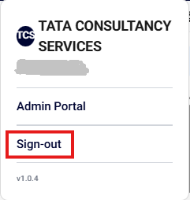
To logout from the application, click the Sign-out option in the top-right corner of the screen.

Create Order

Steps to create order
Follow these steps to create an order in the AgentAssist:
- Complete the offer search criteria using the Search Panel. See Section 3.3 Search Panel
- Review the available flight offers returned by the system. See Section 3.4 Review Offers
- Select the preferred offer and continue with the booking. See Section 3.5 Select Offer
- Enter passenger and contact details for all travelers. See Section 3.6 Passenger Details
- Select seats and services, if required. See Section 3.7 Seat and Services Selection (Optional)
- Review the cart and confirm the order details. See Section 3.8 Order Confirmation
- If payment is pending, click To Pay and complete the payment in ARD Web. See Section 3.9 Payment

Locate “Create Order”
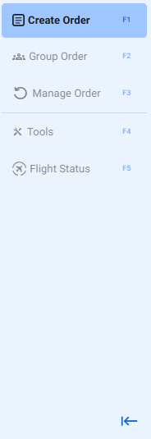
- Look at the left side of the screen
- Locate the vertical menu panel with different options
- Find the option labeled “Create Order”
- Click the arrow at the bottom of the sidebar to collapse the menu for additional workspace or expand it to view all navigation options.

Search Offers
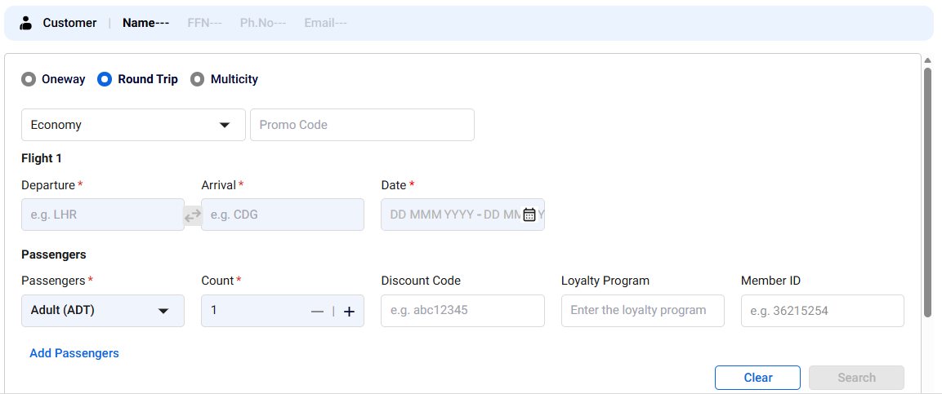
- Use the Search Panel as the starting point for creating and managing bookings.
- From this screen, you can search for available flight offers, modify existing itineraries, compare fares, and assist customers with travel inquiries.
- It is the interface to search for flight offers based on configurable criteria such as trip type, origin/destination, travel dates, passenger details, cabin class, and optional data like promo codes, loyalty programs, and discount codes.

Customer information retrieval from CRM-Salesforce to AgentAssist
- Use the Customer Information Header to review customer details automatically retrieved from Salesforce CRM.
- These details help verify that the booking is being created for the correct customer.
- If a customer cannot be located or the information displayed is incorrect, verify the customer profile in Salesforce CRM before proceeding.
Customer Profile Details

Field | Description
Customer | Indicates that a customer profile has been selected for the booking process
Name | Customer's full name associated from the Salesforce CRM profile
FFN | Frequent Flyer Number registered for the customer
Ph. No | Customer's contact phone number
Email | Customer's registered email address

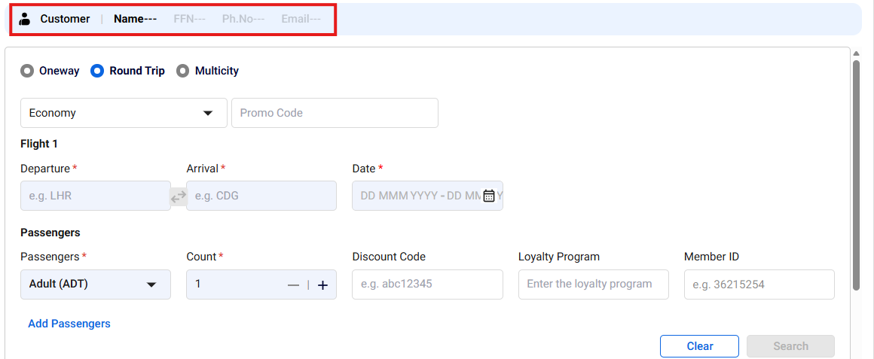

Steps to Search for Flights

Trip Type
- Locate the Trip Type options at the top of the panel
- Select the appropriate option:
  - Round Trip (default and selected in screen) – Search for both outbound and return flights between the same origin and destination
  - One Way – Search for a single flight journey between two locations
  - Multicity – Search for an itinerary containing up to two flight segments (Open-Jaw itinerary)
Round Trip
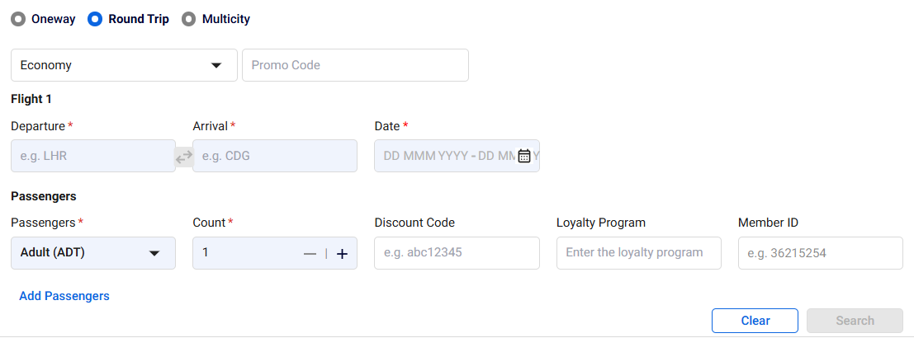

One way
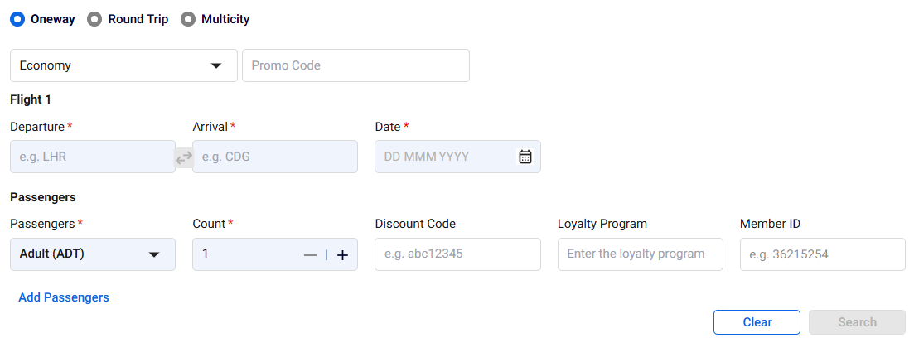
Multi-city (Open-Jaw itinerary)
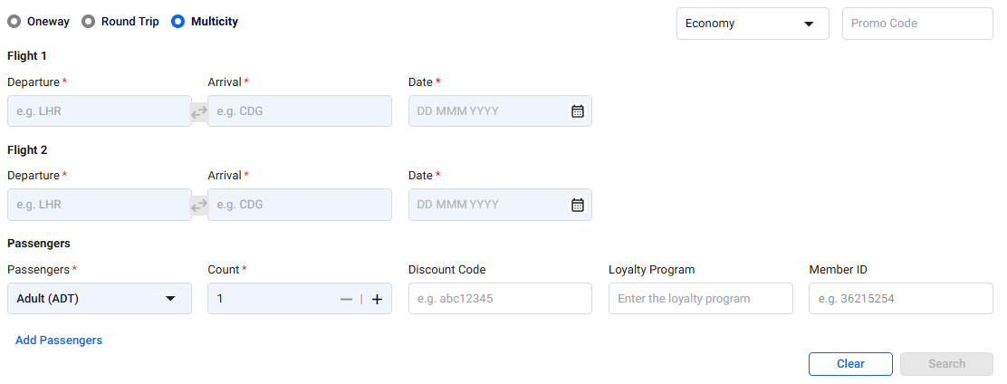

Travel Details
- Locate the Travel Details section in the panel
- Complete all mandatory fields marked with an asterisk (*):
- Departure (*) – Enter the origin location using an Airport Code, City Code, or Country Code.
- Arrival (*) – Enter the destination location using an Airport Code, City Code, or Country Code.
- If required, use the Swap Airports icon (⇄) located between the Departure and Arrival fields:
- After valid Departure airport is entered, the Swap Airports icon (⇄) becomes available between the two Departure and Arrival fields
- Select the Swap Airports icon to quickly interchange the departure and arrival locations
- The system will automatically change the values in the Departure and Arrival fields without requiring the airports to be re-entered manually
- Use this feature when the passenger wishes to reverse the travel direction or when correcting an incorrectly entered route
- Date (*) – Select travel date(s) from the calendar based on the trip selected
- For One way Trip, departure date must be specified
- For Round Trip, both departure and return dates must be specified
  - For Multi-City (Open-Jaw itinerary), a valid date must be entered for each flight segment

Passenger Information
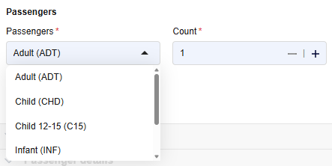
- Locate the Passengers (*) section in the panel
- Select the required Passenger Type:
- Infant (INF) - 0 to 2 years
- Infant with Seat (INS) - 0 to 2 years
- Child (CHD) – 2 to 12 years
- Child 12-15 (C15) – 12 to 15 years
- Adult (ADT) > 12 years
- Set the number of passengers:
- Use the + / – buttons to increase or decrease the passenger count
- Add multiple passenger types (if required):
- Click Add Passengers
- Multiple passengers of the same type can be added separately, as required.
- Select additional passenger types (e.g., Adult + Child)
- Remove Passenger (if required):
- Review the passenger details added to the booking.
- If a passenger entry is no longer required, click the Delete icon at the end of the corresponding passenger row.
- The system will remove the selected passenger type along with any associated information entered for that passenger.
- The Delete icon is available only for additional passenger rows added using Add Passengers.
- When entering passenger details, ensure that the passenger combination complies with the following booking rules:
- A booking may contain a maximum of 9 passengers, excluding infants.
- At least one Adult (ADT) passenger is required in every booking.
- The number of Infants (INF) must be less than or equal to the number of Adults (ADT).
- Each Infant must be associated with an Adult passenger.
- An Adult passenger can be associated with only one Infant.
- If the booking contains only one infant, the association is automatically assigned.
- A booking can accommodate a maximum of 18 passengers in total, consisting of 9 Adults and 9 Infants.

Enter Optional Details (If Applicable)
- Locate the Optional Details section in the panel.
- Confirm with the passenger whether any promotional, discount, or loyalty program details should be applied to the booking.
- If no optional information is available, leave these fields blank and continue with the flight search. Optional fields are not required to perform a flight search but may affect the fares, benefits, and offers returned by the system.

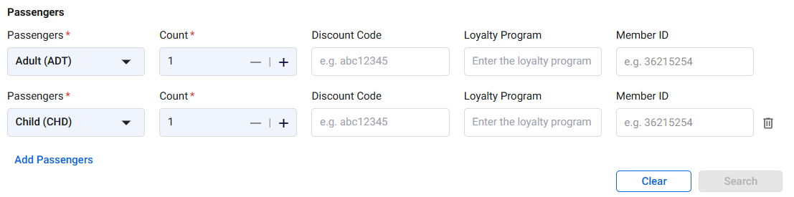

Discount Code
- Select the Discount code from the dropdown list
- This may be passenger-specific based on eligibility

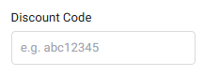
Note : AY (Finnair) does not support the use of Discount Codes. This field is therefore not applicable for AY bookings. Discount code is associated with PTC types.

Loyalty Program
- Select the Loyalty program from the dropdown list
- Ensure it matches the customer’s airline membership

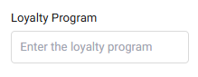
Note: FF Program assignment is supported only at the global booking level. Passenger-level assignments are not currently supported. Any loyalty program entered at the passenger level will be applied only to the first matching passenger in the booking.

Member ID
- Enter the membership ID provided by the customer

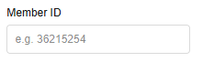

Class Type
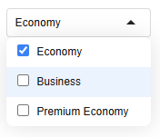
- Locate the Class Type dropdown in the upper-right section of the Search Booking panel.
- The field displays Economy by default when the page is opened.
- Select the dropdown arrow to view the available cabin class options.
- Choose the cabin class requested by the passenger before performing the flight search.

Promocode

- Locate the Promo Code field immediately to the right of the Class Type dropdown.
- Manually enter the promo code provided by the customer.
- Ensure the promo code is entered exactly as provided, including any letters, numbers, or special characters.
- Leave the field blank if the passenger does not have a valid promotional code.
- Both fields apply to the entire flight search. The selected cabin class and any entered promo code will be considered when retrieving eligible flight offers and fares.

Search and Validation

- Click Clear Button to reset all entered search criteria.
- Click Search Button to retrieve available flight offers.
- If any validation errors are displayed:
- Review and correct the required fields
- Re-enter missing or incorrect details

Review Offers
When all mandatory criteria in the Offer Search panel are entered and validated, the system conducts the search. The system retrieves flight offers matching the defined criteria and displays them for review.

One way review screen

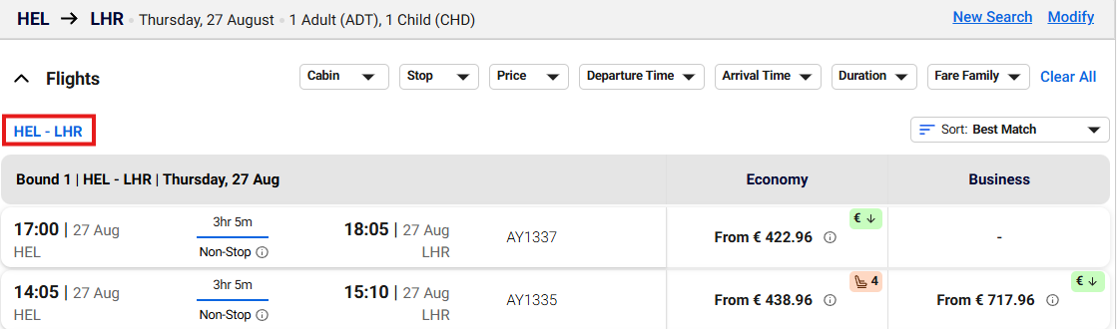

Round trip review screen
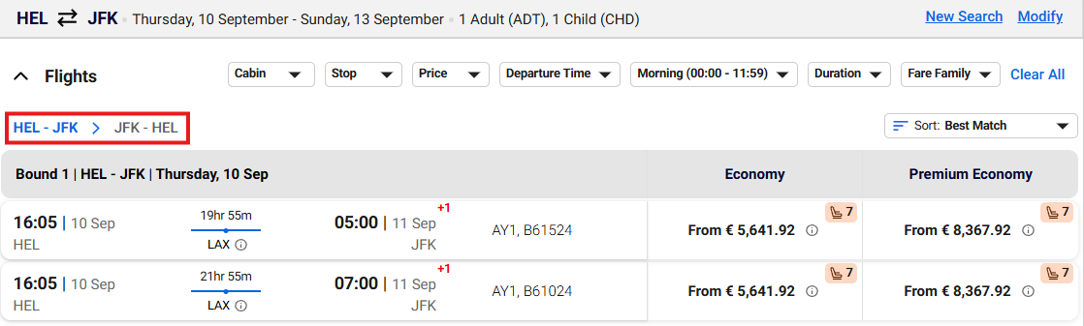
Special indicators
- - highlights the lowest fare available from the search results
- - A limited seats indicator is displayed when availability is less than 8 seats
- indicator is shown when the flight arrives on the next day

Flight Results Overview – Offers, Filters, and Fares
The screen shows the Flight Offers (Search Results) page after clicking Search. You will see:

Header section
The header section displays the selected route, travel date, and passenger count, allowing agents to quickly verify the current search criteria before reviewing the flight results.

Filtering options
The filter section provides options such as Cabin, Stop, Price, Departure Time, Arrival Time, Duration, and Fare Family, enabling agents to refine and narrow down flight results based on customer preferences.

Sorting options
The sorting section includes options such as Best Match (default), Departure Time, Arrival Time, Duration, and Total Price, allowing agents to organize flight results based on preferred criteria.
- When a sorting option is selected, results are displayed in ascending order by default.
- Clicking the same sorting option again will toggle the results to descending order.
- This behavior applies to Departure Time, Arrival Time, Duration, and Total Price options.
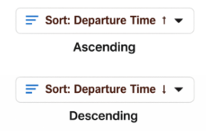

Flight Results Table (Main Section)
Each row represents one flight offer with:
  - Departure time & airport (e.g., 17:20 HEL)
  - Arrival time & airport (e.g., 19:10 JFK)
  - Duration & stops (Non-stop / with stops like CDG, LHR)
  - Flight number (e.g., AY15)
  - Fare options - Price displayed for each fare
    - Economy
    - Premium Economy

Managing Filters and Search Options
- Click on “Clear All” available near the filter options to reset all applied filters and this does not change the original search criteria (route/date)
- Click on the “Modify” option at the top-right of the screen if you want to edit the existing search criteria.
- Click on the “New Search” option at the top-right of the screen to clear current search. It takes you back to a blank Search Panel.

- Here is summary of options:
Options | Actions
Clear All | Removes applied filters only
Modify | Edits current search criteria
New Search | Starts a completely new search

Information Icon – Flight Details
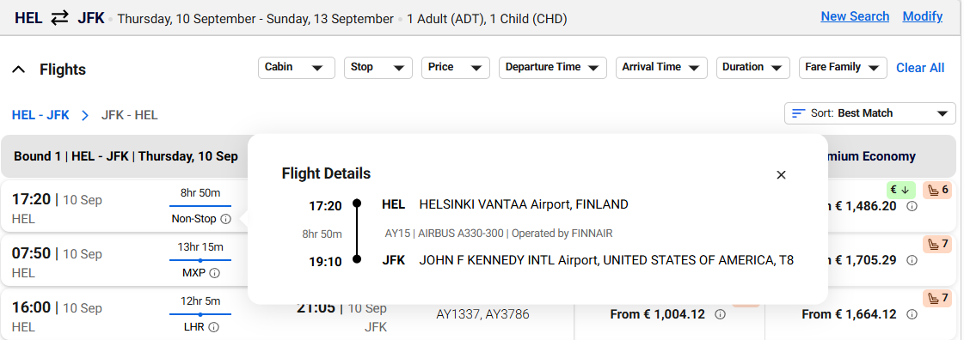

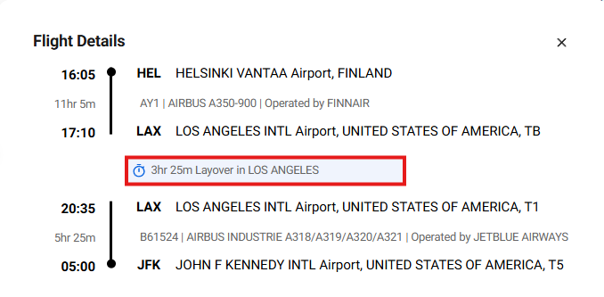
- When reviewing a selected flight offer, click the information icon to view detailed journey information. The Flight Details window provides additional information about the itinerary, including flight segments, airports, timings, layovers, aircraft type, and operating airline.

- You will see:
- Departure time and departure airport for each flight segment.
- Arrival time and arrival airport for each flight segment.
- Flight duration for each segment.
- Flight number and operating airline.
- Aircraft type of flight segment.
- Terminal information, where available.
- For connecting itineraries, layover location and layover duration.
- An indication of whether the itinerary is a Non-Stop or Connecting Flight.
- Click the Close (X) button to exit the popup

Information Icon – Pricing Details
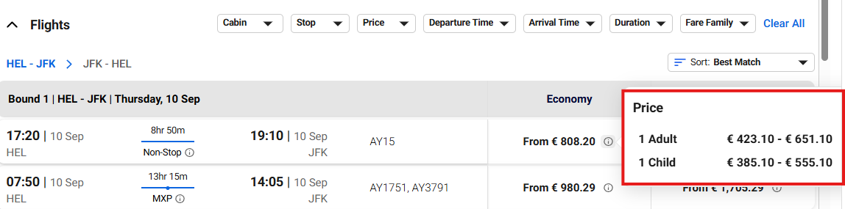
- Clicking on information icon opens a price popup
- Review fare details for each passenger type
- Click the Close (X) button to exit the popup

Select Offer

Fare Family Review
- After reviewing the available flight offers, you can click the price displayed under the Economy or Business cabin column to view the available Fare Families for the selected itinerary.
- When a fare is selected, the system expands the fare options and displays all available fare families for the chosen cabin class.
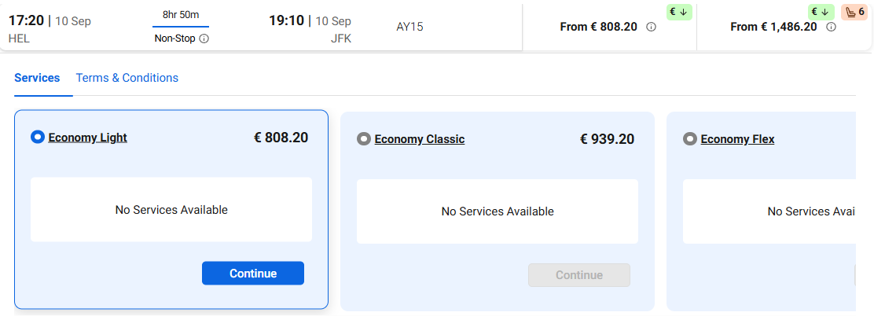
You will see:
- Available fare families for the selected cabin (e.g., Economy Superlight, Economy Classic, Economy Flex).
- The total fare amount for each fare family.
- Services and benefits included in each fare family.
- Terms and Conditions applicable to the selected fare.
- A Continue button to proceed with the selected fare family.

Compare Fare Families
Review the fare options with the customer and compare:
- Fare price.
- Included services and benefits.
- Fare conditions and restrictions.
- Refundability and flexibility, where applicable.
- Any additional entitlements available with higher fare families.
Services Tab
- Select the Services tab to view the services included with each fare family.
- Depending on the fare selected, services may include baggage allowance, seat selection, flexibility options, and other travel benefits.
- If no services are included, the message "No Services Available" will be displayed.
Terms & Conditions Tab
- Select the Terms & Conditions tab to review the fare rules and restrictions.
- Carefully review any restrictions that may impact changes, cancellations, refunds, or other booking modifications.
- Explain applicable fare conditions to the customer before proceeding.

Note: The Services and Terms & Conditions sections are currently not populated. The relevant information will be made available in a future iterative release.

Offer Selection
- Click the fare displayed under the preferred cabin class (Economy or Business).
- Review the available fare family options.
- Select the fare family that best meets the customer's travel requirements.
- Review the included services and applicable terms and conditions.
- Click “Continue” on the selected fare family to proceed with the booking.

Cart Creation and Management
- Selecting an offer creates a Cart at the right corner of the screen as shown below:
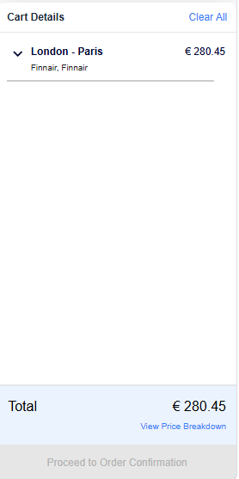

Viewing Selected Cart Details
- Click on a cart entry in the Cart Details panel to expand and view the complete itinerary details.
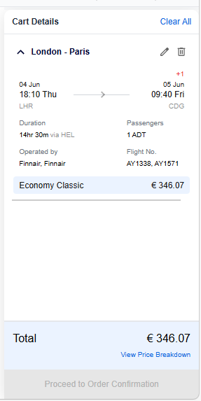
- The expanded view displays:
  - Origin and destination cities (e.g., London - Paris)
  - Departure and arrival dates/times
  - Departure and arrival airport codes
  - Total journey duration and connection information
  - Number and type of passengers
  - Operating carrier(s)
  - Flight number(s)
  - Selected fare product and price
Additional Actions Available
- Edit: Modify the selected itinerary or fare selection.
- Delete: Remove the itinerary from the cart.
- Clear All: Remove all itineraries currently added to the cart.
- View Price Breakdown: Display a detailed fare breakdown, including taxes and applicable charges.
- Proceed to Order Confirmation: Click Proceed to Order Confirmation to continue with the booking process and review the order details before final submission. This option becomes available only after all required passenger information has been entered and completed successfully.
Note: The cart can be expanded or collapsed using the arrow icon beside the itinerary. When expanded, complete flight and pricing details are displayed for agent review before proceeding with the booking.
- Any modification to flight or services:
  - Triggers cart revalidation
  - May update price based on availability

Passenger Details
Once order is selected, this screen ensures all required passenger and contact details are entered before proceeding to the next step of booking. The Passenger Details section displays a separate tab for each passenger included in the booking.

Passenger Tabs
- Each passenger is displayed in an individual tab, identified by passenger type and sequence number (for example, Adult (ADT) 1, Adult (ADT) 2, Child (CHD) 1, and Infant (INF) 1).
- Select a passenger tab to enter or review details for that specific passenger

Passenger Details Entry
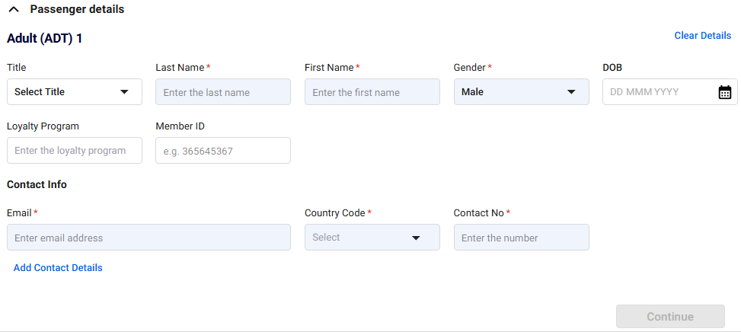
Agents must enter the passenger and contact information required to complete the booking. Fields marked with an asterisk (*) are mandatory.
- Title (*) – Select the passenger's title from the drop-down list.
- Last Name (*) – Enter the passenger's surname exactly as it appears on the travel document.
- First Name (*) – Enter the passenger's given name exactly as it appears on the travel document.
- Gender (*) – Select the passenger's gender from the drop-down list.
Date of Birth (DOB)
  - Conditional for Adult (ADT) passengers based on secure flights.
  - Mandatory for Child (CHD), Infant (INF), Infant with Seat (INS) and C15 passengers.
  - If provided for an Adult, the age calculated from the DOB must fall within the valid age range configured for an Adult passenger.
  - For Child and Infant passengers, the DOB must be entered and must meet the applicable age validation rules.
  - The system will display an error if the entered DOB does not correspond to the selected passenger type.
- Loyalty Program – Enter the airline loyalty or frequent flyer program name, if available.
- Member ID – Enter the membership number associated with the selected loyalty program.

Contact Details Entry
- Email (*) – Enter a valid email address to receive booking confirmations and travel notifications.
- Country Code (*) – Select the appropriate country dialing code.
- Contact Number (*) – Enter the passenger's contact telephone number.
- Add Contact Details – Click to provide additional contact information if required.

Reusing Contact Information
- When multiple passengers are included in the booking, enable Use the same contact information as Adult 1 to automatically copy the contact details from the primary adult passenger, eliminating the need to re-enter the information.
Infant Association
For Infant passengers, an additional section is displayed:
- Travelling with (*) – Select the Adult passenger with whom the infant will travel.
- Select Association (*) – Choose the appropriate accompanying adult from the list. Each infant must be associated with an adult passenger.

Validation Rules
- Enter a valid email address in standard format (e.g., name@domain.com).
  - Must follow standard format: name@domain.com
  - No spaces or missing characters allowed
  - System validates format before allowing continuation
- Phone number format based on country
  - Only valid numeric input accepted as per country rules
- DOB must match passenger type (e.g., Adult, Child, Infant)
  - Must match selected passenger type:
  - Adult (≥ 12 years)
  - Child (2–12 years)
  - Infant (0–2 years)
  - System restricts mismatched age entries
- At least one phone number and one email address must be provided per order.
Other Controls
- “Clear Details” option resets all entered passenger and contact information
  - Resets all entered passenger and contact information.

- “Continue” button will be enabled only after all mandatory fields are completed
Enabled only after:
  - All mandatory fields are completed
  - All validations are satisfied

Passenger Data Submission
- Passenger details must be entered for all passengers in the booking.
- Once all mandatory details are provided, the Continue button will be enabled.
- Clicking the Continue button will add the passenger details to the cart.
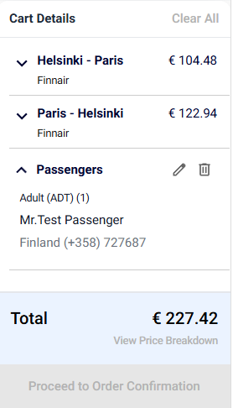

Seats and Services Selection (Optional)
Upon completion of passenger details, the system directs to the Seats and Services selection, where additional services can also be selected.

Screen Overview
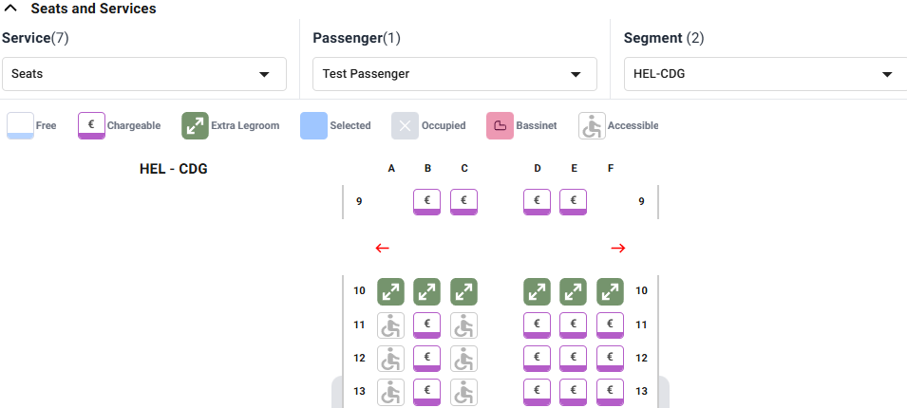
This screenshot shows the Seats section of the booking workflow, where an agent can assign or manage seats for a passenger on a selected flight segment.
- Passenger:
Use the Passenger drop-down to choose the traveler for whom the seat assignment is being made.
- Segment:
Use the Segment drop-down list to select the flight leg for which seats need to be managed. For itineraries containing multiple flight segments, select the required segment to view and assign available seats for that portion of the journey.

Seats Selection
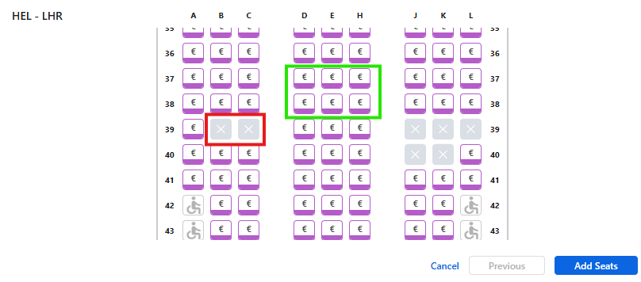

- Available and unavailable seats can be viewed directly on the seat map.
- Select the seats for all itinerary if necessary
- Click “Add seats” to update the selected seats in the cart.
- Cancel and Previous buttons are available to:
- Cancel the current selection
- Navigate between different itineraries during seat selection
- Chargeable seats are indicated with a € symbol.
- Click on an available seat to select the chosen passenger.
- Selected seats will be highlighted for confirmation.

Services Selection
Use the Service drop-down list to select the type of ancillary service to be managed for the selected passenger and flight segment. Selecting a service displays the corresponding options and details available for that passenger and journey segment.
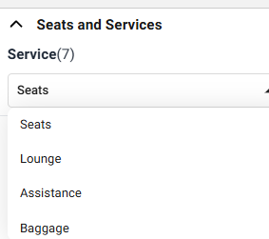
- Select the required service by clicking the corresponding checkbox.
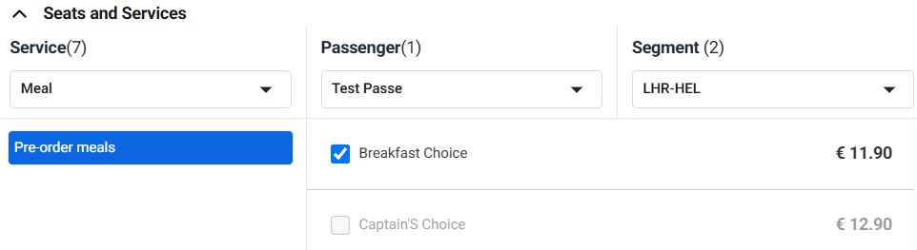
- Select one or more services, if allowed by the airline and system rules.
- Verify that the selected services are highlighted before proceeding.
- Click Clear All to remove all selected services, if required.
- Click Add Service to add the selected service(s) to the cart for the chosen passenger and flight segment.
- Review the cart to confirm that the selected services have been added successfully.

Note: The maximum number of services that can be added depends on the available service quota. Service addition is not allowed once the configured limit is exceeded.

Cart Review
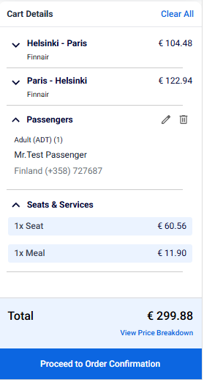
- To view the price breakdown, click on “View Price Breakdown”
- Review all itinerary, passenger, and service details before proceeding
- Ensure all required services and selections are accurate
- Modify or remove items if necessary, using the available controls
- Click “Proceed to Order Confirmation” button to confirm the order

Order Confirmation
This screen serves as the final order management page, where agents can review order details.
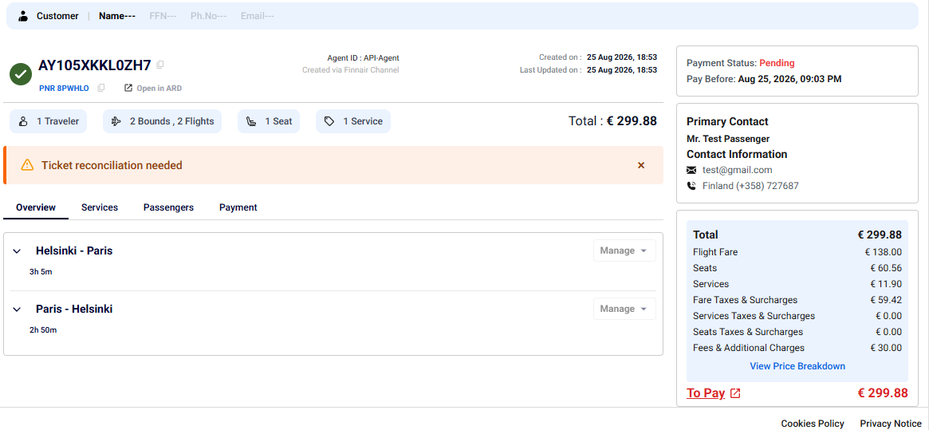
- Review all order details, including itinerary, passengers, seats, and services.
- Use navigation tabs to verify specific sections.
- Upon successful confirmation, the system generates:
- Order ID
- Record Locator (PNR)

Payment
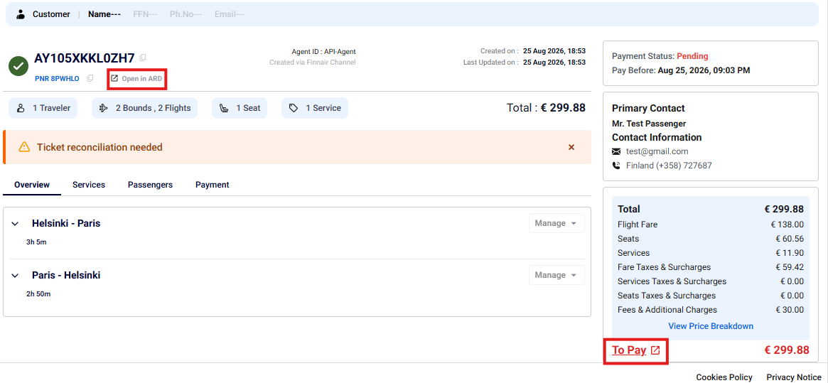
- On the order confirmation screen, the payment status is Pending. Click on the To Pay button.
- The system redirects ARD Web to continue the payment process.
- The PNR is retrieved automatically in ARD Web.
- Perform the payment in ARD Web by following the existing payment flow.

End-to-End Booking Flow (Visual Diagram)
┌──────────────────────────────┐
│ Salesforce CRM │
└──────────────┬───────────────┘
│
▼
┌──────────────────────────────┐
│ Click "Create Order" │
└──────────────┬───────────────┘
│
▼
┌──────────────────────────────┐
│ AgentAssist Opens │
│ (New Tab) │
└──────────────┬───────────────┘
│
▼
┌──────────────────────────────┐
│ Search Panel │
│ Enter Route, Date, Pax, Class│
└──────────────┬───────────────┘
│
▼
┌───────────────┐
│ Validate? │
└───────┬───────┘
│Yes
▼
┌──────────────────────────────┐
│ Search Flights │
└──────────────┬───────────────┘
│
▼
┌──────────────────────────────┐
│ Flight Results Page │
│ (Filters, Sorting, Pricing) │
└──────────────┬───────────────┘
│
▼
┌──────────────────────────────┐
│ Compare & Select Flights │
│ (Time • Price • Cabin • Fare)│
└──────────────┬───────────────┘
│
▼
┌──────────────────────────────┐
│ Select Offer │
│ (Fare Card) │
└──────────────┬───────────────┘
│
▼
┌──────────────────────────────┐
│ Cart Created │
│ (Flight + Fare Stored) │
└──────────────┬───────────────┘
│
▼
┌──────────────────────────────┐
│ Enter Passenger Details │
│ (Name, DOB, Gender, Contact)│
└──────────────┬───────────────┘
│
▼
┌───────────────┐
│ Validation? │
└───────┬───────┘
│Yes
▼
┌──────────────────────────────┐
│ Seat Selection (Optional) │
└──────────────┬───────────────┘
│
▼
┌──────────────────────────────┐
│ Add Services (Optional) │
│ (Baggage, Meals, WiFi, etc.) │
└──────────────┬───────────────┘
│
▼
┌──────────────────────────────┐
│ Review Cart │
│ (Flight, Pax, Price, Extras) │
└──────────────┬───────────────┘
│
▼
┌──────────────────────────────┐
│ Order Confirmation │
│ (PNR Generated) │
└──────────────┬───────────────┘
│
▼
┌──────────────────────────────┐
│ Click "To Pay" │
└──────────────┬───────────────┘
│
▼
┌──────────────────────────────┐
│ Redirect to ARD Web │
└──────────────┬───────────────┘
│
▼
┌──────────────────────────────┐
│ Complete Payment │
└──────────────┬───────────────┘
│
▼
┌──────────────────────────────┐
│ Booking Confirmed │
│ (Order ID + PNR + Status) │
└──────────────┬───────────────┘

Use Case: Family Booking (Adult + Child + Infant)

Detailed Scenario Understanding
- Family of 3 traveling together
- Adult (primary traveler)
- Child (needs seat + services)
- Infant (no seat, must be linked to adult)
- Customer expects:
  - Convenience (fewer layovers)
  - Seating together
  - Baggage included

Step 1: Understand Customer Need
Before starting:
- Ask:
  - “Do you prefer direct flights?” (important for families)
  - “Do you want seats together?”
  - “Do you have baggage or stroller requirements?”
Why important?
Family travel decisions are based more on comfort and convenience than price alone

Step 2: Search Configuration
- Select Round Trip
- Enter route + dates
- Add passengers:
  - 1 Adult
  - 1 Child
  - 1 Infant
Critical Validations
- Infant ≤ Adult
- Infant age must be 0–2 years
- Child age must be 2–12 years

Agent Insight:
If DOB is wrong → system will throw validation error later

Step 3: Flight Selection Strategy
Now agent must think differently than normal booking:
Prefer:
- Non-stop flights
- Short layovers
- Family-friendly timings (not red-eye flights)
Avoid:
- Tight connections (risk with child + infant)
- Long waiting times at airport
Decision Example Instead of cheapest flight:
- Choose slightly higher price with less travel stress

Step 4: Fare Selection Logic
Agent must carefully check:
- Does fare include baggage?
- Are seats included or paid?
- Is it refundable or flexible?
Why is it important? Family plans may change → flexibility matters

Step 5: Passenger Entry

Adult:
- Normal entry

Child:
- Enter DOB carefully
- Must fall into 2–12 years category

Infant:
- Enter DOB < 2 years
- System requires linking infant to adult

Important Rule
- 1 Infant = must be assigned to 1 Adult
- Infant does not get seat

Step 6: Contact Details
- Always use adult as primary contact
- Ensure:
  - Phone number reachable during travel
  - Correct email address for sharing tickets & notifications

Step 7: Seat Selection Strategy
Agent must ensure:
- Adult + Child sit together
- Infant sits with adult
Best Practice
- Choose seats in same row
- Prefer aisle/window combo for comfort
Avoid:
- Splitting family across rows

Step 8: Services Selection
Recommend:
- Checked baggage
- Infant services (if airline provides)
- Meal selection (optional)
Explain charges clearly to customer

Step 9: Final Review
Agent must double-check:
- Passenger types correctly assigned
- Infant linked to adult
- Seats are together
- Correct baggage selection

Step 10: Confirmation and Payment
- Generate PNR
- Complete payment
- Share details with customer

Glossary

Terms | Descriptions
ARD | Amadeus Reservation Desktop web application used for payment and post-booking servicing
Booking / Order | The complete reservation created for a passenger, including flights, services, and payment details
Cart | Temporary storage of selected flights, passengers, seats, and services before final confirmation
Cabin Class | Travel class selected by the passenger (e.g., Economy, Premium Economy, Business)
Fare Family | Group of fares with specific rules and benefits such as baggage, flexibility, and refundability
Flight Offer | Available flight option returned based on search criteria
Itinerary | The complete journey plan including flight segments (departure and arrival details)
PNR | Passenger Name Record – unique booking reference generated after order confirmation
Passenger Type | Category of passenger such as Adult (ADT), Child (CHD), or Infant (INF)
Search Panel | Interface used by agents to enter travel details and search for flight offers
Sorting | Functionality that allows arranging search results based on criteria such as time, duration, or price
Filter | Option used to refine search results based on preferences like stops, price, or cabin
Ancillary Services | Additional services such as seats, meals, or baggage added to a booking
Validation | System checks to ensure all mandatory fields and correct data are entered before proceeding
Segment | A single leg of a journey (e.g., HEL → LHR)
Order Confirmation | Final review screen where booking details are confirmed and PNR is generated

Appendix A
This appendix provides supplementary information to help agents better understand system behavior, validation rules, and commonly used configurations within the AgentAssist.

System Guidelines and Additional Notes
- All mandatory fields marked with (*) must be completed before proceeding.
- Passenger types must comply with defined age rules (Adult, Child, Infant).
- Maximum number of passengers allowed per booking is 9 excluding infants
- The number of infants (INF) must not exceed the number of adults (ADT).
- Sorting and filtering options help refine and organize flight search results efficiently.
- Payment are handled via the ARD web application.

Common Validation Rules and System Messages
Scenario | Validation Rule | System Message / Behavior | Resolution
Missing mandatory field | Required field not filled | Validation error displayed | Enter required details
Invalid email format | Incorrect email structure | “Enter valid email address” | Provide correct email format
Same origin and destination | Departure = Arrival | Validation error | Select different airports
Infant exceeds adult count | INF > ADT | System restriction | Reduce infant count or increase adults
Passenger limit exceeded | More than 9 passengers | System restriction | Reduce passenger count
Seat not selected | No seat chosen | “Seat not assigned” displayed | Select seat if required
Payment pending | Order not paid | Status shows “Pending” | Click To Pay and complete payment
Invalid travel date | Incorrect or past date | Validation error | Select valid future date

About Tata Consultancy Services (TCS)
Tata Consultancy Services is an IT services, consulting and business solutions organization that has been partnering with many of the world’s largest businesses in their transformation journeys for over 56 years. Its consulting-led, cognitive powered, portfolio of business, technology and engineering services and solutions is delivered through its unique Location Independent Agile™ delivery model, recognized as a benchmark of excellence in software development.
A part of the Tata group, India's largest multinational business group, TCS has over 612,000 of the world’s best-trained consultants in 55 countries. The company generated consolidated revenues of US $29 billion in the fiscal year ended March 31, 2024, and is listed on the BSE and the NSE in India. TCS' proactive stance on climate change and award-winning work with communities across the world have earned it a place in leading sustainability indices such as the MSCI Global Sustainability Index and the FTSE4Good Emerging Index.
Visit www.tcs.com and follow TCS news at @TCS_News.

All content / information present here is the exclusive property of Tata Consultancy Services Limited (TCS).
The content / information contained here is correct at the time of publishing. No material from here may be copied, modified, reproduced, republished, uploaded, transmitted, posted or distributed in any form without prior written permission from TCS. Unauthorized use of the content / information appearing here may violate copyright, trademark and other applicable laws, and could result in criminal or civil penalties.
Copyright © 2026 Tata Consultancy Services Limited

